Task No: 13  Date:29/10/25 | Data analytics using MapReduce program on weather dataset | CO2  K3

AIM: To Construct MapReduce program to perform data analysis on weather dataset.
PROCEDURE:
Step 1: Set up Hadoop Cluster
Before you start, ensure you have a Hadoop cluster set up and running. You will need Hadoop installed, configured, and a Hadoop Distributed File System (HDFS) where your dataset is stored.
Step 2: Write Mapper and Reducer Classes
Create two Java classes, one for the Mapper and one for the Reducer.
Step 3: Configure and Run Hadoop Job.
Create a Hadoop job configuration and submit the job
Step 4: Compile and Package
Compile your Java code, create a JAR file, and include all dependencies (e.g., Hadoop libraries) in the JAR.
Step 5: Run the MapReduce Job
IMPLEMENTATION:
class WeatherAnalysis(MRJob):
def mapper(self, _, line):
try:
fields = line.strip().split(',')
if len(fields) == 8:
year = fields[0].split('-')[0]
temperature = float(fields[1])
yield year, temperature
except ValueError:
pass
def reducer(self, year, temperatures):
temperatures = list(temperatures)
average_temperature = sum(temperatures) / len(temperatures)
yield year, round(average_temperature, 2)
if __name__ == '__main__':
WeatherAnalysis.run()
OUTPUT:
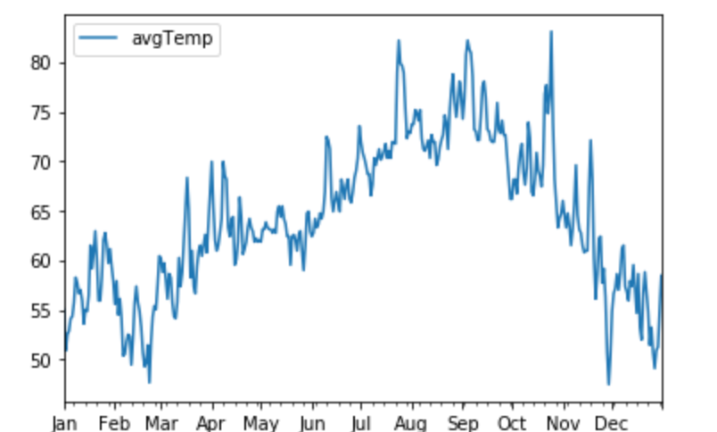

RESULT:
Thus, Implemented Mapreducer Program to perform data analysis on weather dataset successfully.

